**TAKE 5! HMS Summer Checkout 2019**



Hull Media Center invites students to borrow up to FIVE books of their choice and read them over the summer! In order to take advantage of summer checkout, we have a few requirements. You must:

* Be a rising 6th, 7th, or 8th grade student at Hull Middle School
* Return all materials previously borrowed (All 2018-2019 books are due on May 15, 2019) and pay for any lost books or fines.
* Not be planning to dis-enroll or move away from Hull before the next school year.
* Turn in this permission form when you check out books May 16th-20th.
* READ!
* **Return all books before August 8th, 2019.** There will be a return box in the lobby all summer and at Open House.
* If your child does not return to Hull, you are responsible for returning the books in person or mailing them to 1950 Old Peachtree Rd, Duluth GA 30097

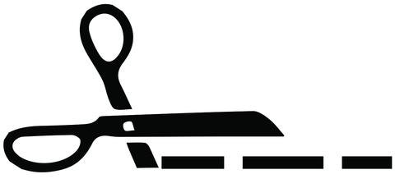

_ __ __ __ __ __ __ __ __ __ __ __ __ __ __ __ __ __ __ __ __ __ __ __ __ __ __ __

**Hull Summer Checkout Permission**

**Please bring this form with you to check out your summer books between May 16th and 20th!**

Student Name: _____________________________ Student number: _______________________ Rising grade: ___

--I give my student permission to check out books from Hull Middle over the summer.

**My child may borrow this many books (circle one number): 1 2 3 4 5**

-- I understand that if the books are lost, damaged, or not returned, a replacement fee of $15/paperback and $20/hardback will be placed on my child’s account.

-- I do not plan to dis-enroll my child from Hull or leave the Hull district over the summer. If my situation changes, I will return the books to Hull Middle in person or by mail.

-- I understand that these books must be returned by August 8th, 2019.

Parent/Guardian Signature: __________________________________________________ Date: ________

Parent email:___________________________________________________________________________